DOCUMENT MANAGEMENT
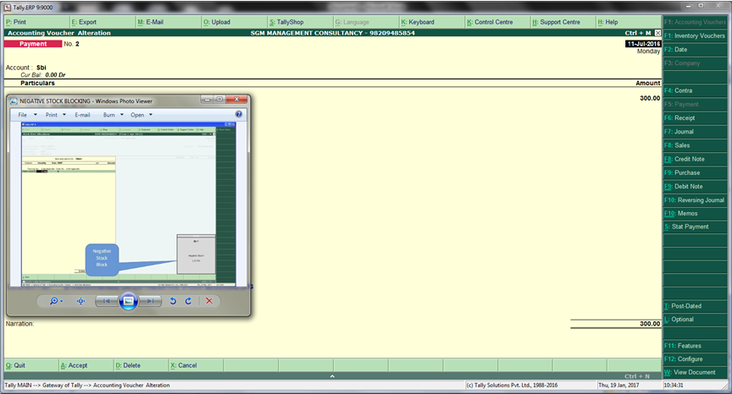
View Document

